## User Guide

### Web Application

### Checker Application

#### Validate card

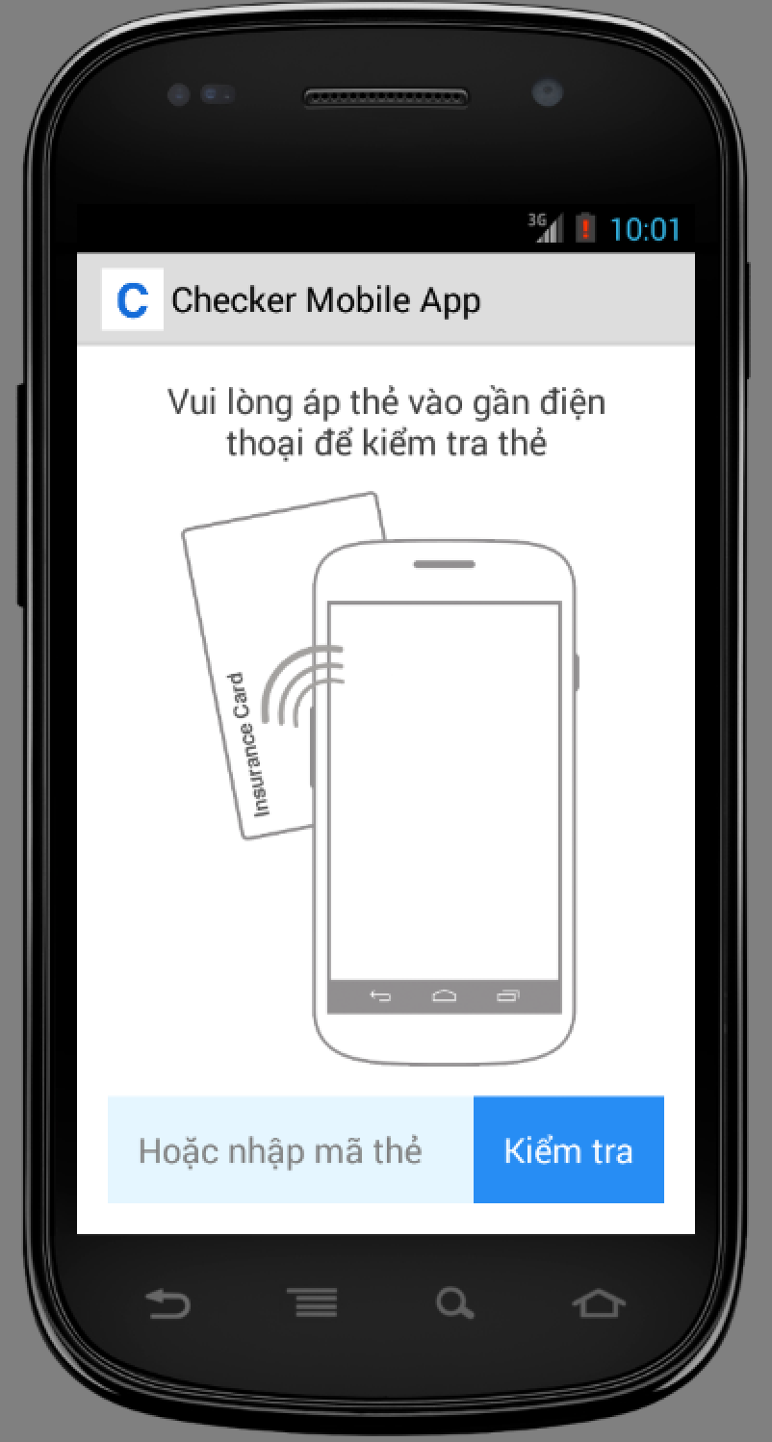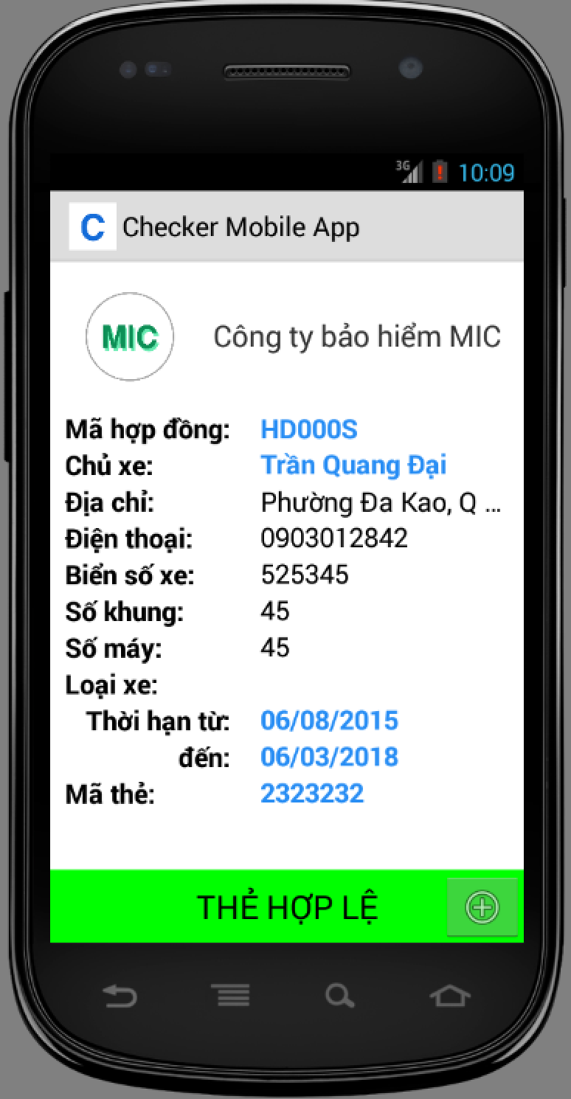

|  |  |
| --- | --- |
| Step | Description |
| 1 | Put Card close to the phone |
| 2 | Check information from the output screen |

#### Add punishment information

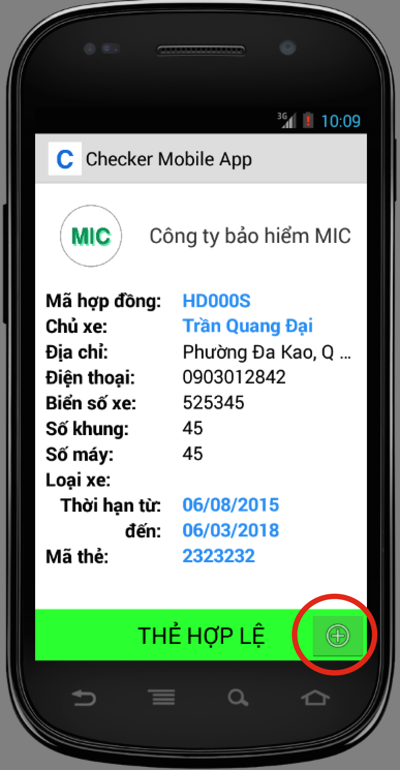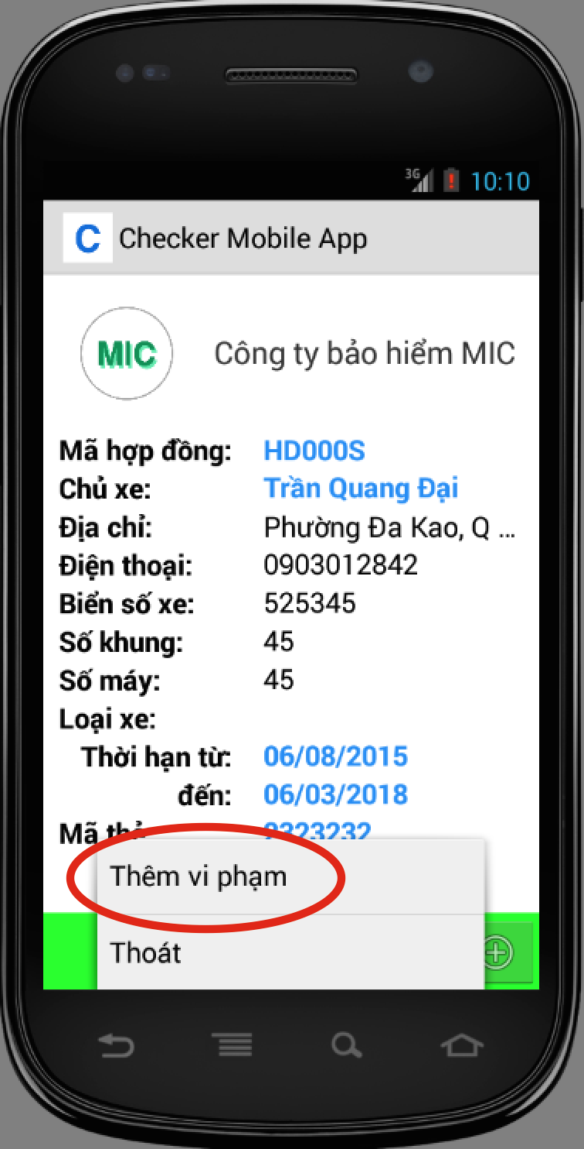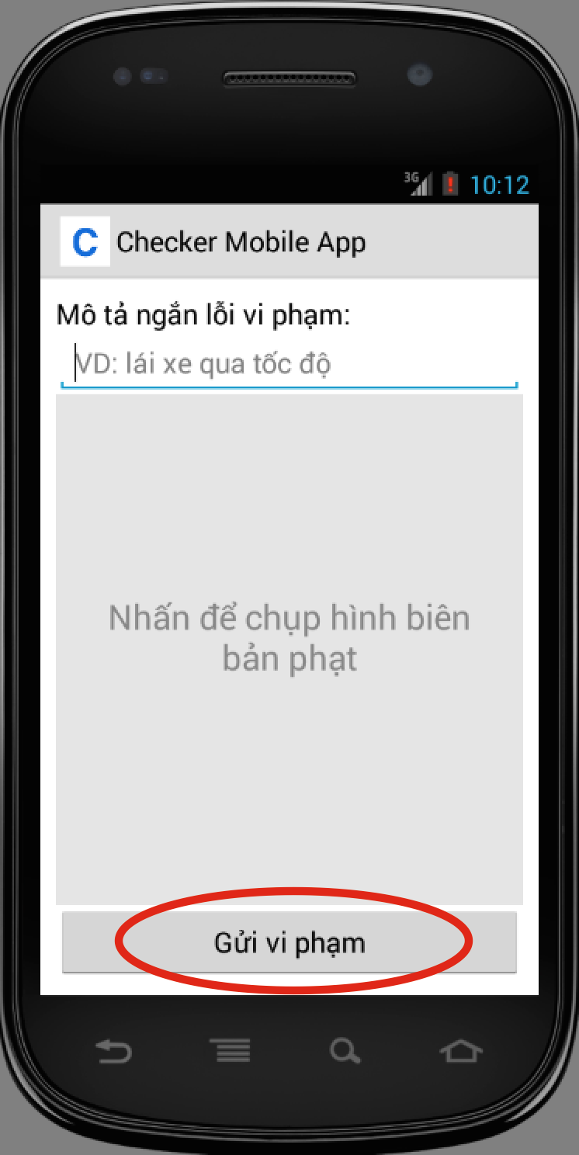

|  |  |
| --- | --- |
| Step | Description |
| 1 | At output screen, tap the plus button at bottom right corner. |
| 2 | Tap “Thêm vi phạm” button, application open new screen to enter punishment information |
| 3 | Press “Gửi vi phạm” to send punishment information |

### Printer Application

#### Print card

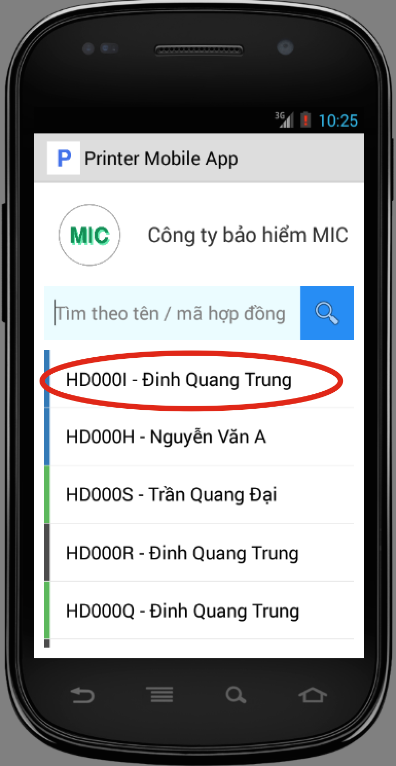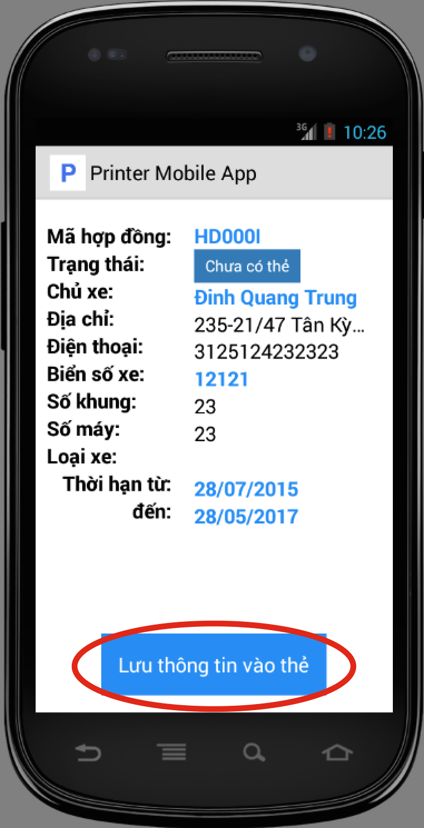

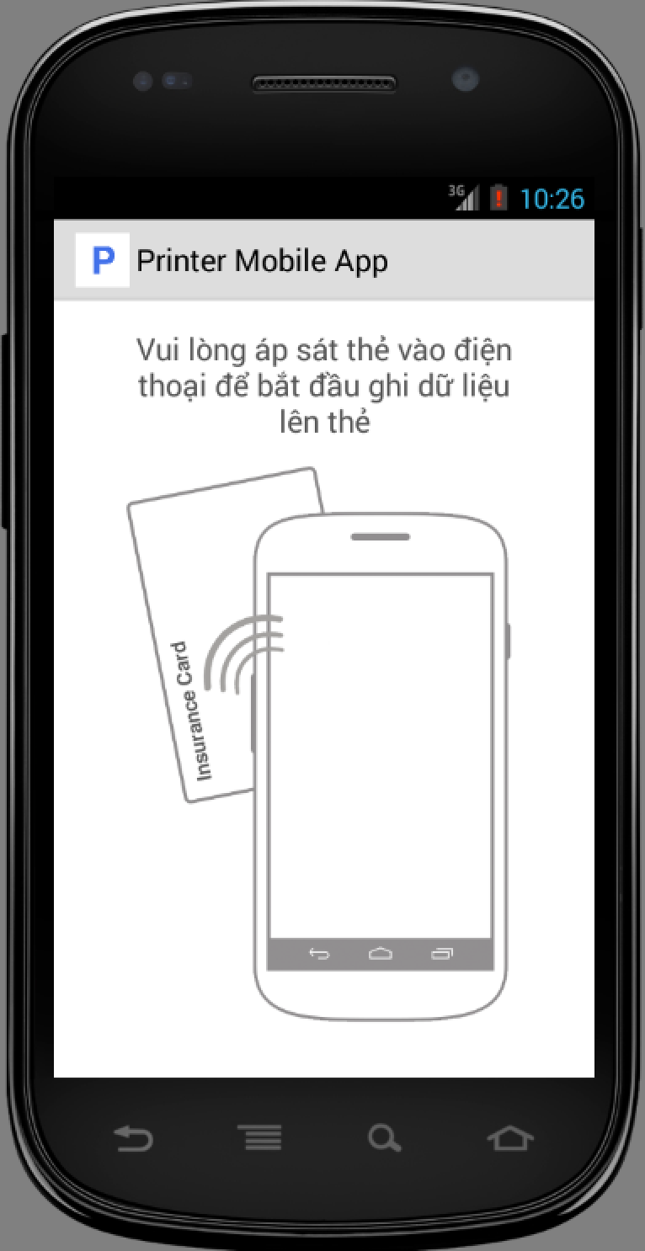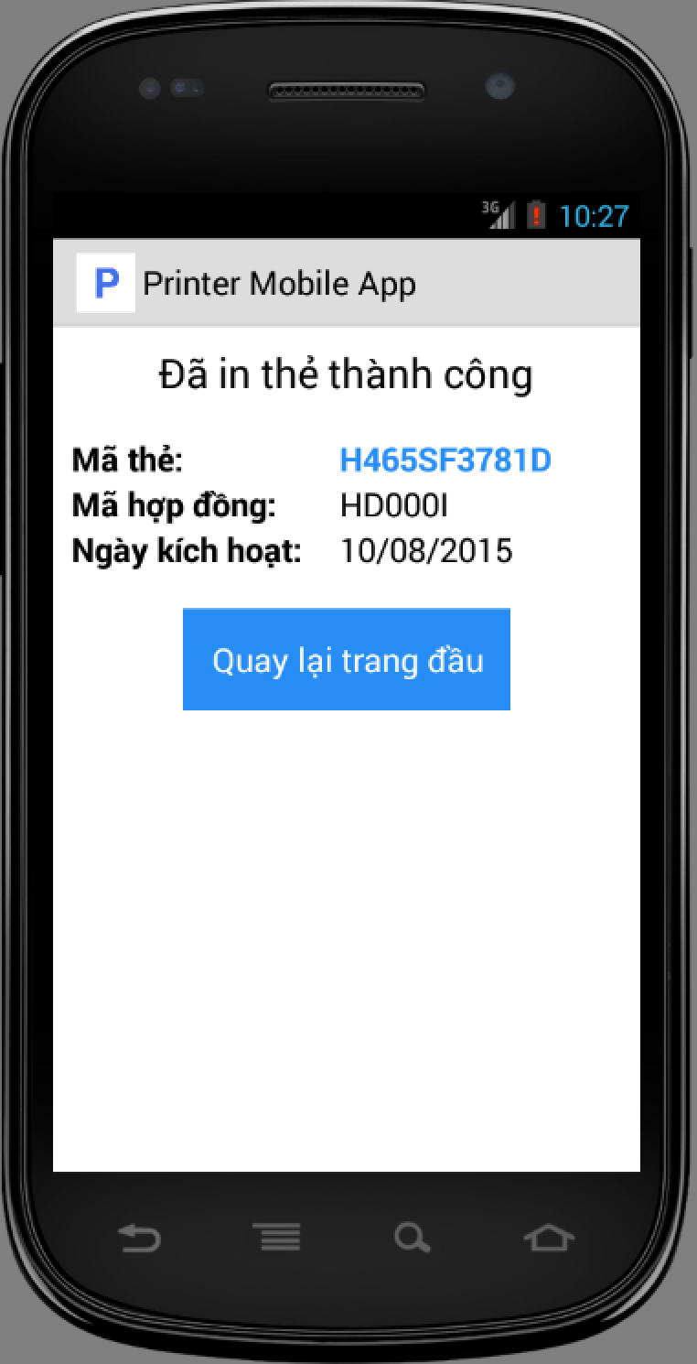

|  |  |
| --- | --- |
| Step | Description |
| 1 | At home screen, select a contract from list. |
| 2 | Tap “Lưu thông tin vào thẻ” button |
| 3 | Put NFC card close to phone, application show print result |